# CASE STUDY

**ON**

# AWS ROUTE 53

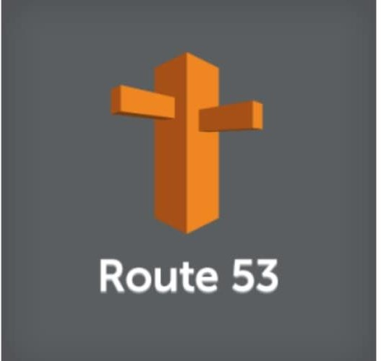

**INTRODUCTION**

Amazon Route 53 is a highly available and scalable Domain Name System (DNS) web service. You can use Route 53 to perform three main functions in any combination: domain registration, DNS routing, and health checking.

If you choose to use Route 53 for all three functions, be

sure to follow the order below:

## Register domain names

Your website needs a name, such as example.com. Route 53 lets you register a name for your website or web application, known as a *domain name*.

1. **Route internet traffic to the resources for your domain** When a user opens a web browser and enters your domain name (example.com) or subdomain name (acme.example.com) in the address bar, Route 53 helps connect the browser with your website or web application.

## Check the health of your resources

Route 53 sends automated requests over the internet to a resource, such as a web server, to verify that it's reachable, available, and functional. You also can choose to receive notifications when a resource becomes unavailable and choose to route internet traffic away from unhealthy resources.

**Route 53** provides the user with several benefits. They are:

* Highly Available and Reliable
* Flexible
* Simple
* Fast
* Cost-effective
* Designed to Integrate with Other AWS Services
* Secure
* Scalable

**HANDS ON**

**Step 1:** Type route 53 on search bar of the management console

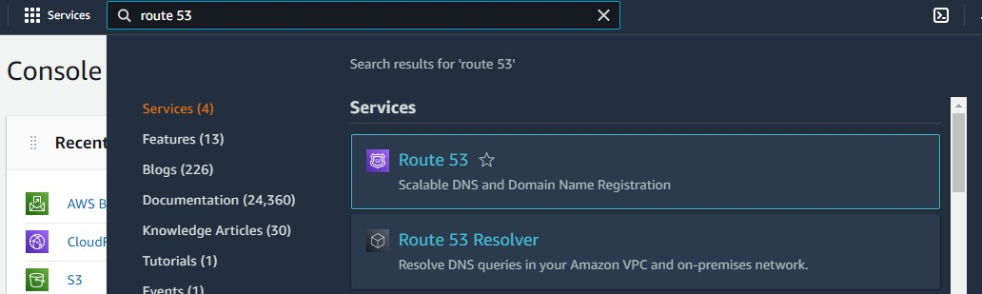

**Step 2:** Below dashboard will appear when you click on route 53. Here first we will be register on domain which cost some amount. So, click on register domain

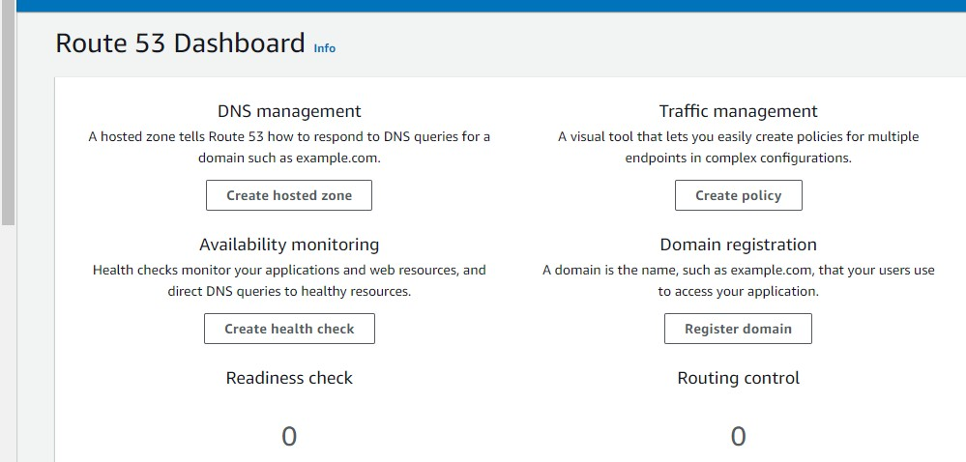

**Step 3:** Give the name of your domain which you want to create and check for the availability .As you can see this domain is not available so check for the other domain

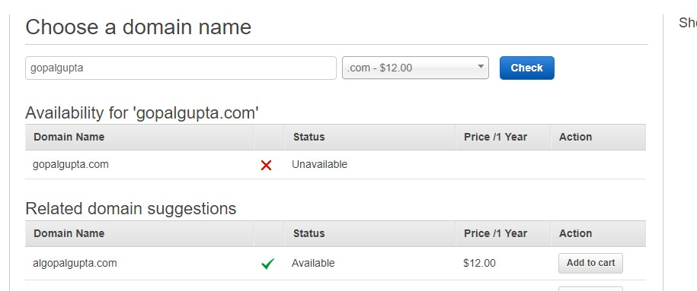

**Step 4:** Once the domain is available. Click to add to cart and click on continue

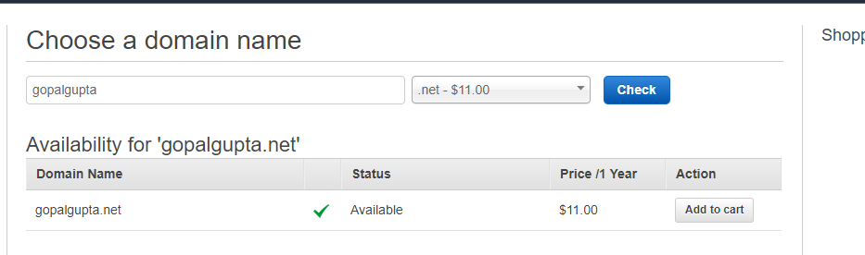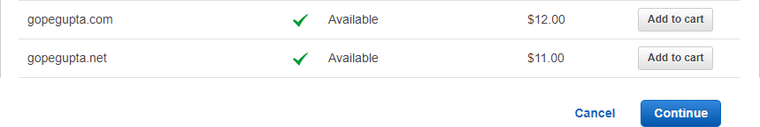

**Step 5:** After that fill the registrant contact and click to continue. After that you will be redirected to payment page . For this demon I am not doing payment process.

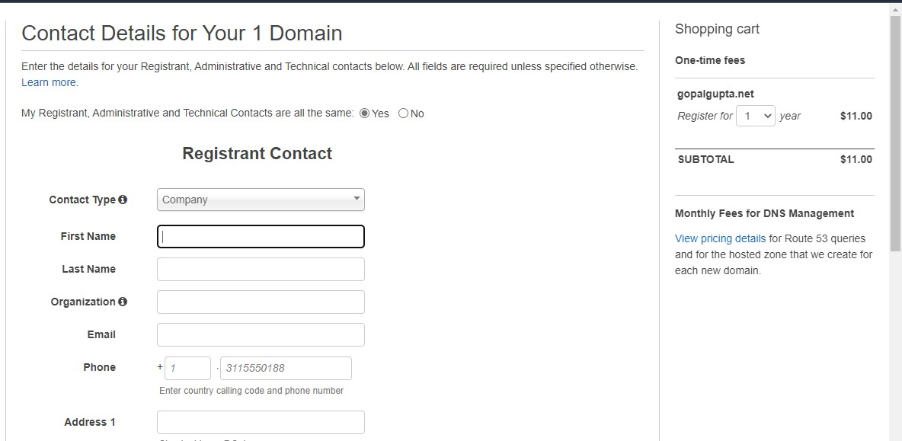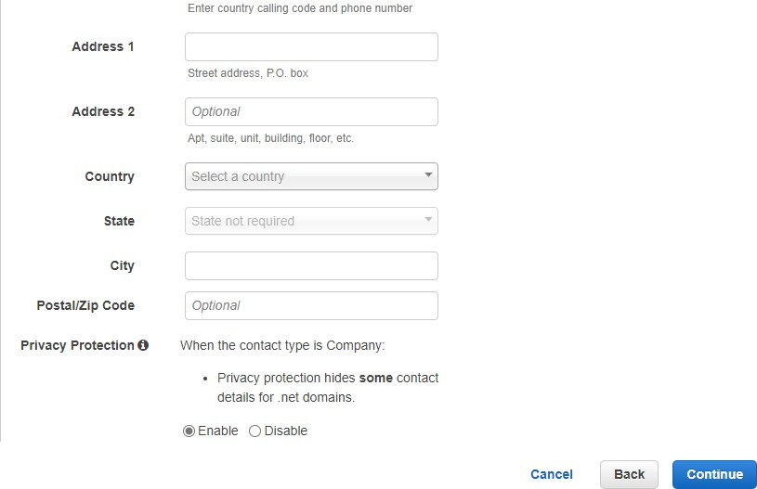

**Demo for DNS management**

**Step 1:** In Route 53 dashboard click on **Create Hosted Zone**

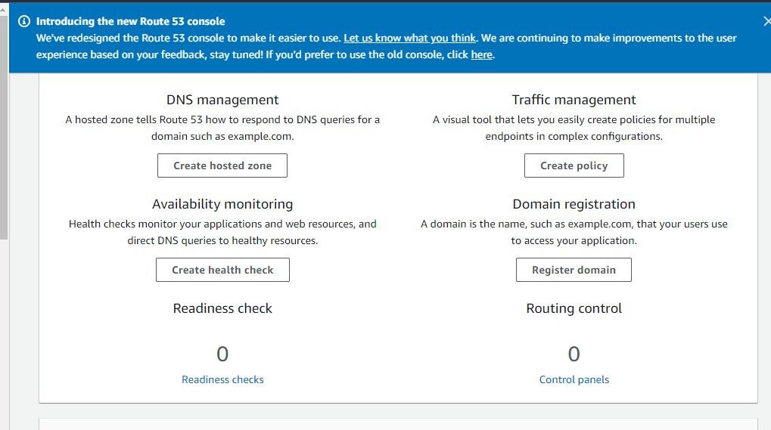

**Step 2:** Give the name of your domain and click on

## create hosted Zone

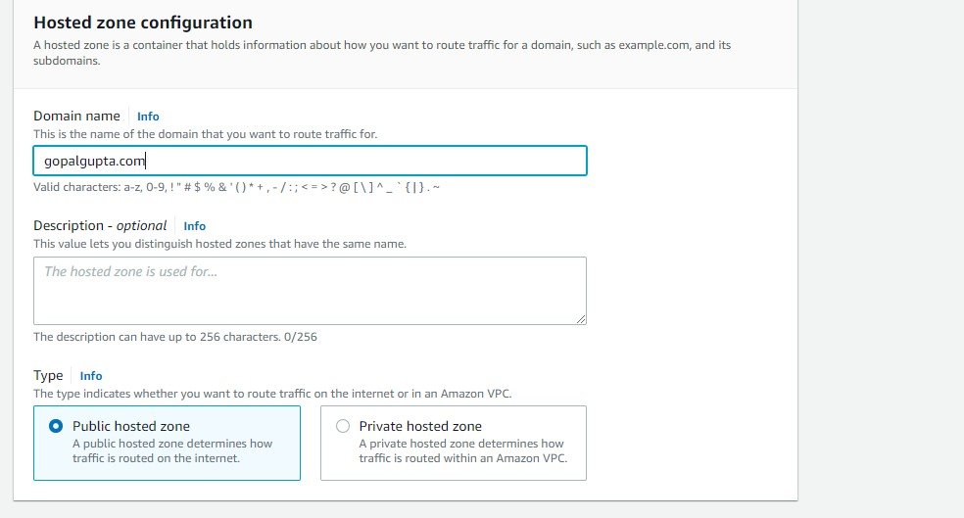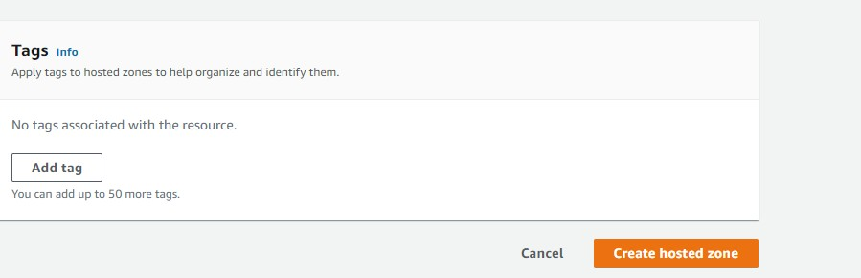

**Step 3 :** You can see hosted zone has been created now click on domain name

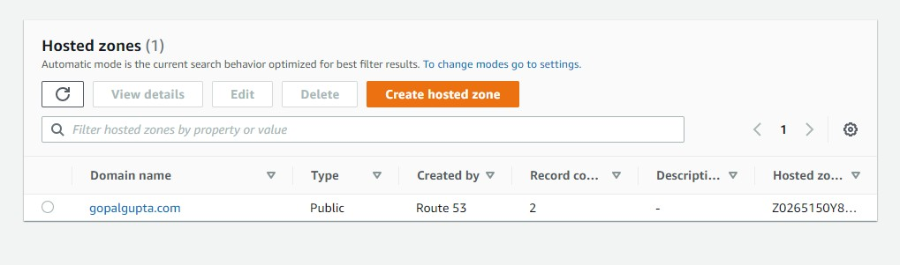

**Step 4:** Now we have to create record . So click on

## create record.

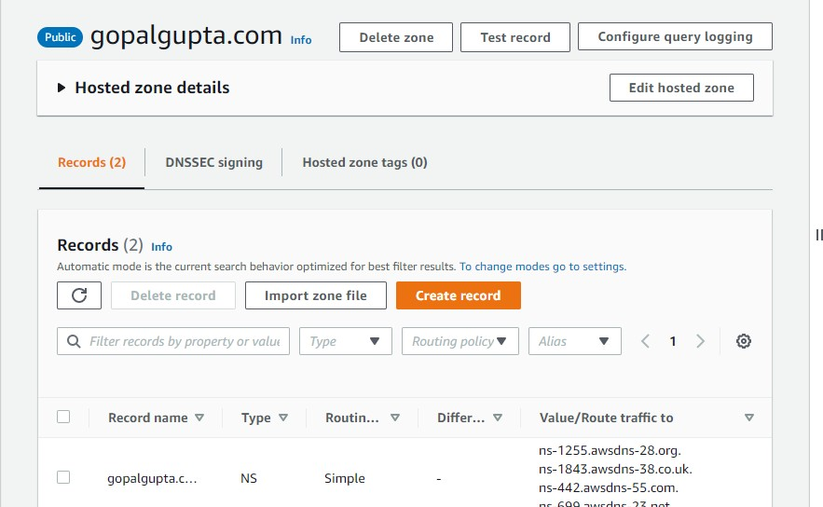

**Step 5:** Give the record name as [www.](http://www/) And select record type as A , keep all things as default and click on create

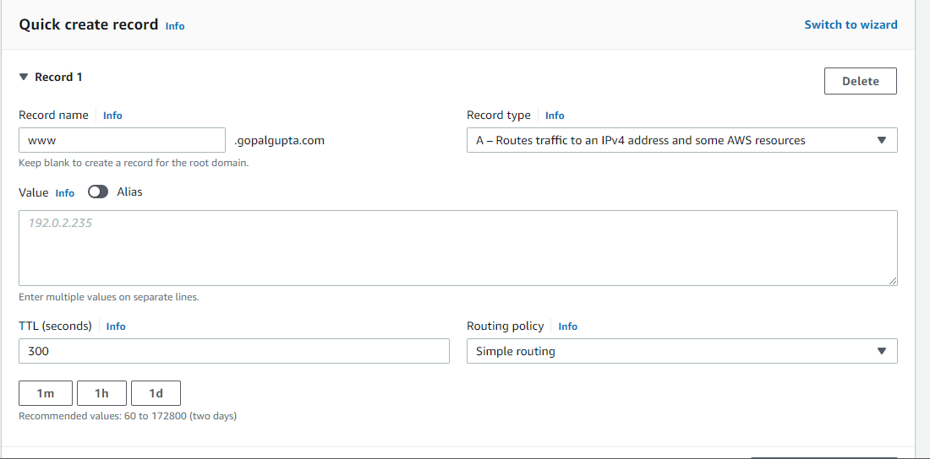

**Step 6:** You can see record has been created .

